Table of Contents

Class12: Workflow Designer 1000 Footstep 1

Workflow 1

SharePoint Designer 2

Changes by using SP and SPD 3

1.Give description on Root site 3

SPD 3

View 4

Site Pages 5

Site Asset 5

Data Source 5

Site group 6

Subsite 6

Blog 6

Default pages 7

All File 7

Catalog 11

create New Form 11

# Class12: Workflow Designer 1000 Footstep

Read: SharePoint design work flow

(Doc. = 003)

1. SharePoint Designer 2013 => [Download SharePoint Designer 2013 from Official Microsoft ...](https://www.microsoft.com/en-us/download/details.aspx?id=35491) =>   
   sharepointdesigner_64bit.exe =>

## Workflow

Open any List => List =>Workflow setting **or** List setting =>workflow

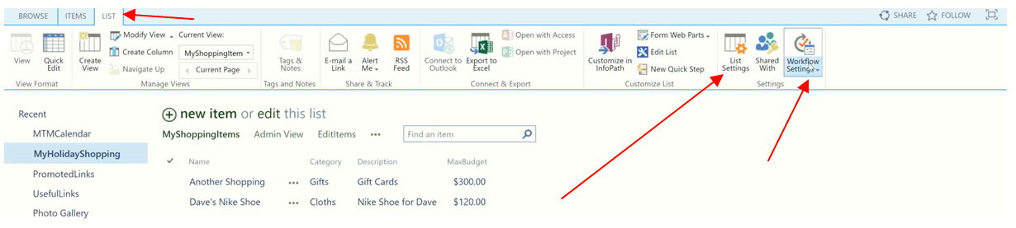

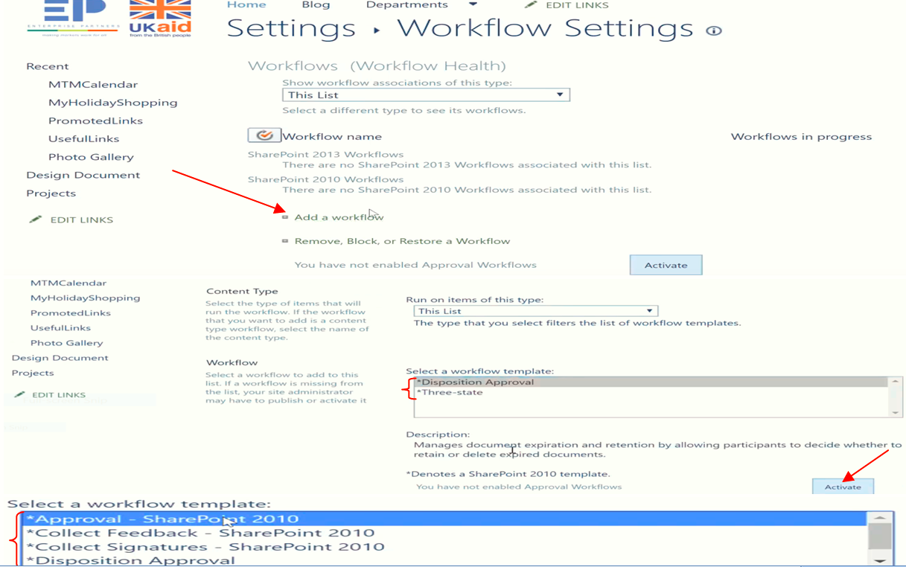

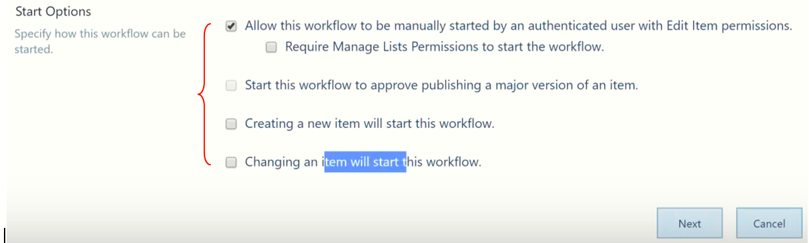

## SharePoint Designer

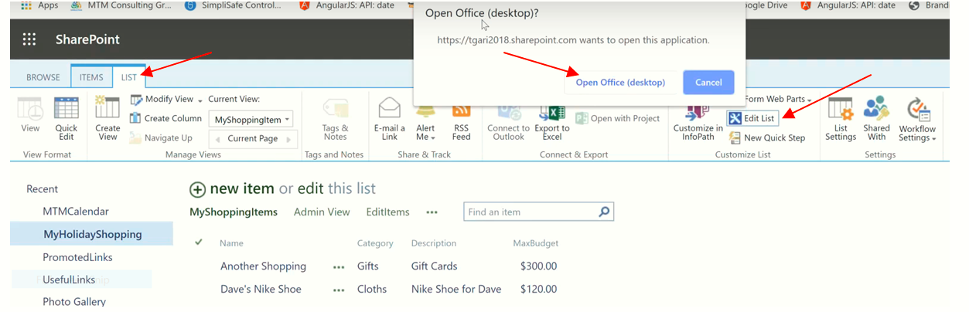

Say **Yes** => Put your SharePoint (**Username and Password**)

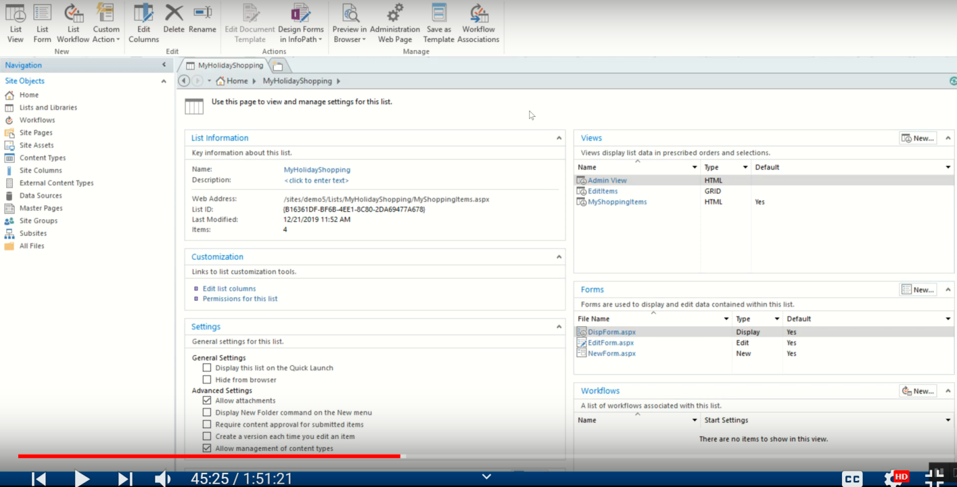

Changes by using SP and SPD**.**

### 1.Give description on Root site

#### SPD

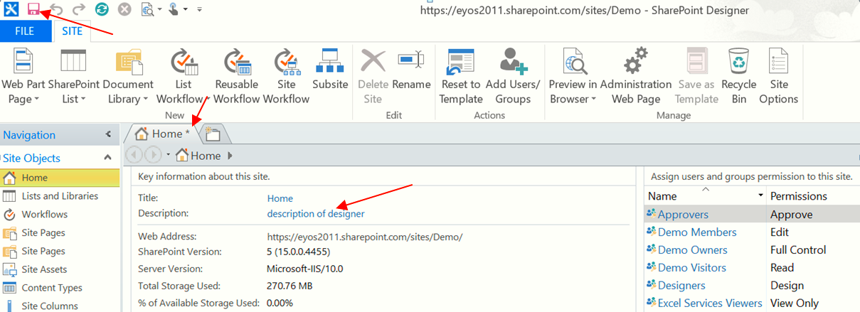

**Go to SP Site**

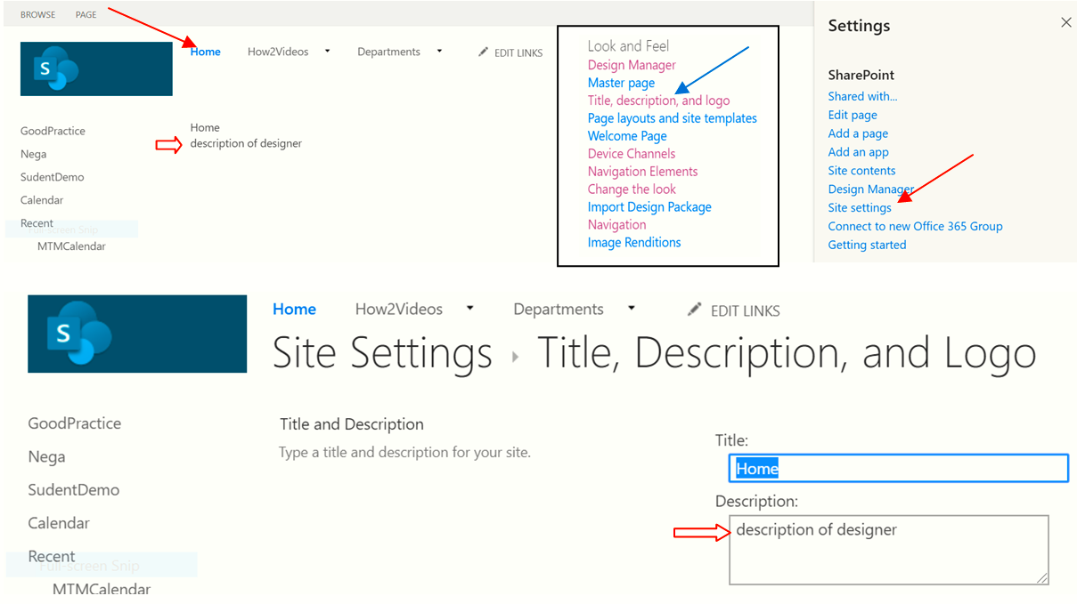

**Home:**

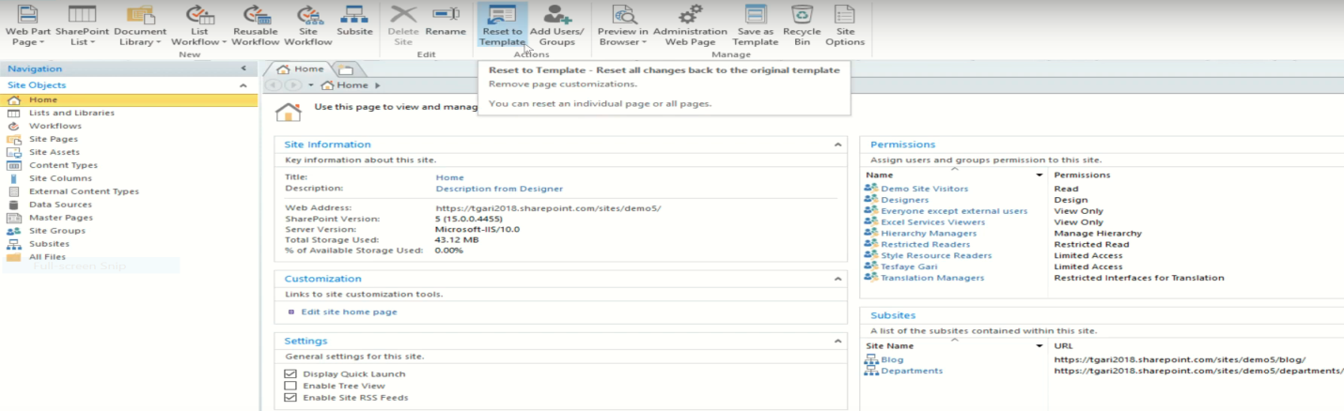

**List and Library:**

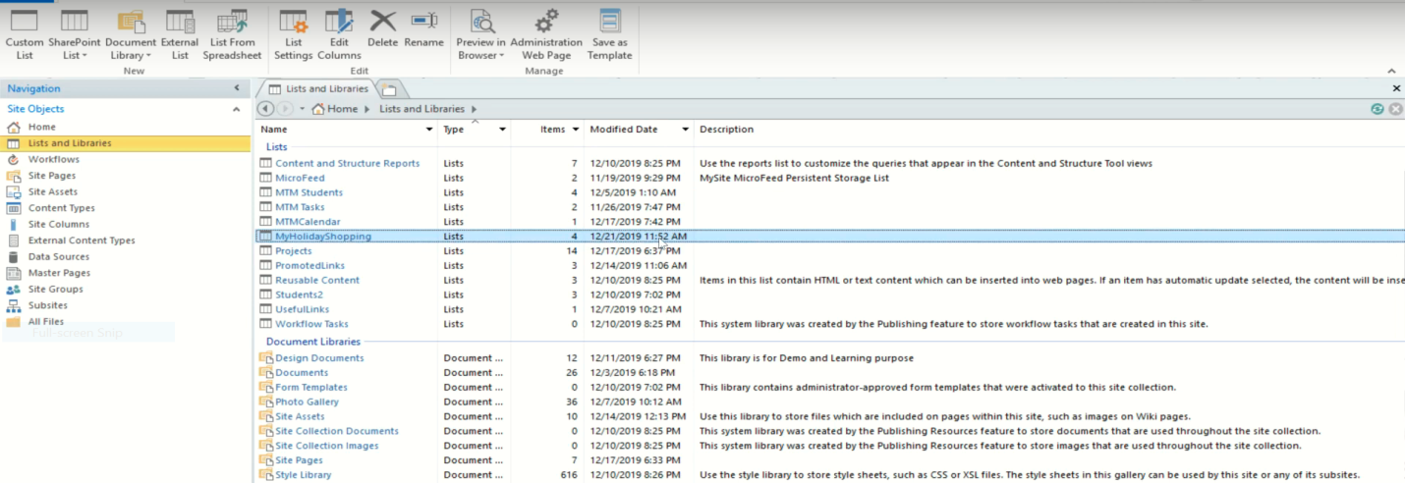

View**:**

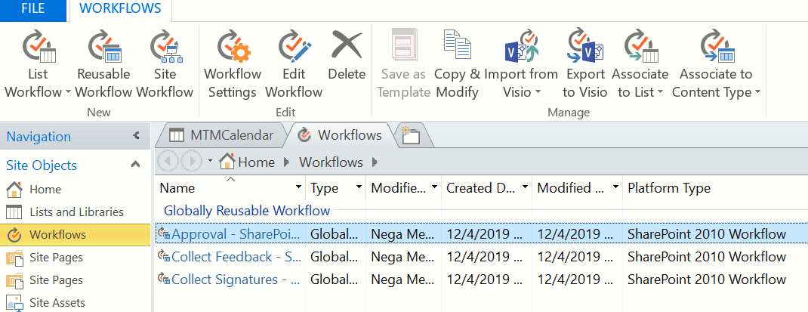

This come from the above activated

Site Pages**:**

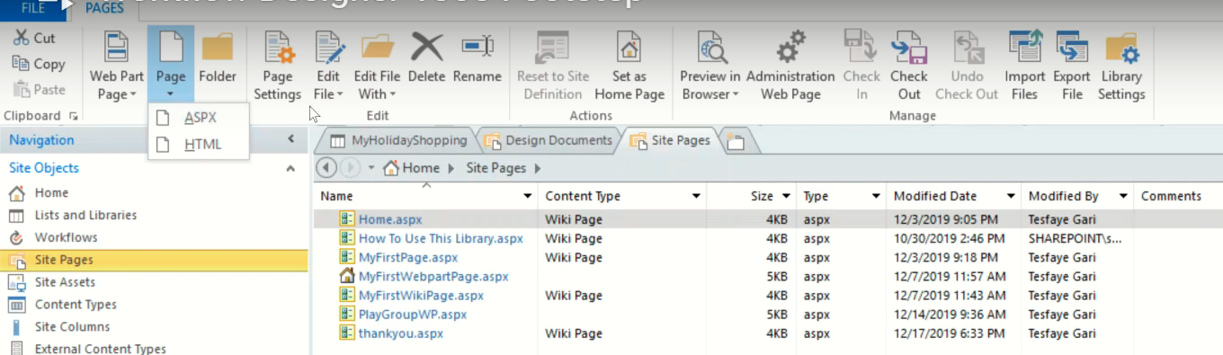

Site Asset**:**

If we upload some photos on this page, then we get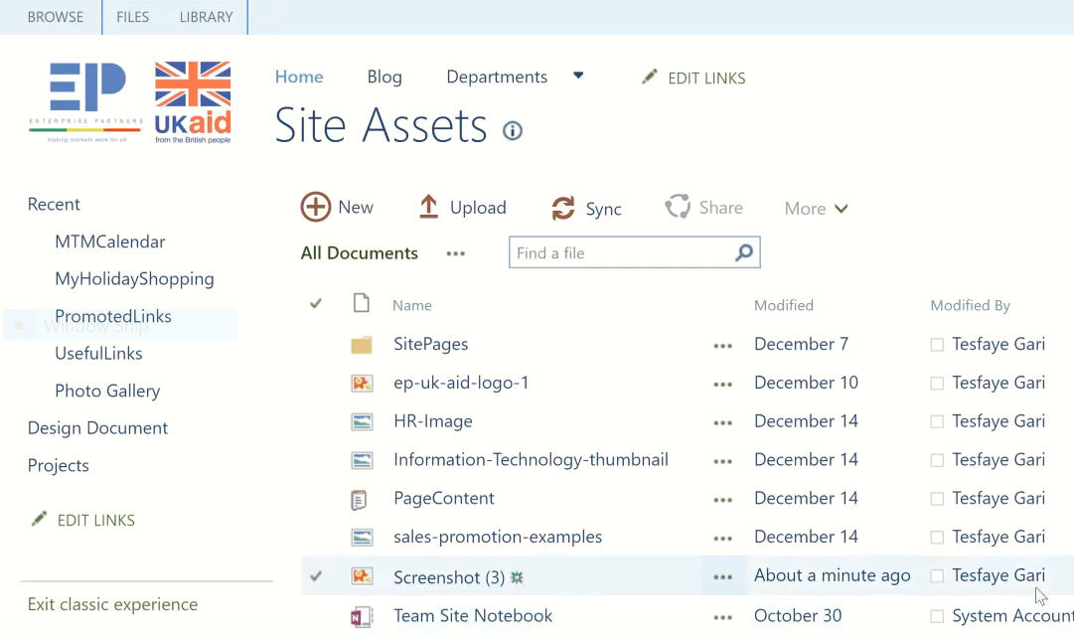

Data Source**:**

**NB**: Data source means **Lists** and **Libraries**

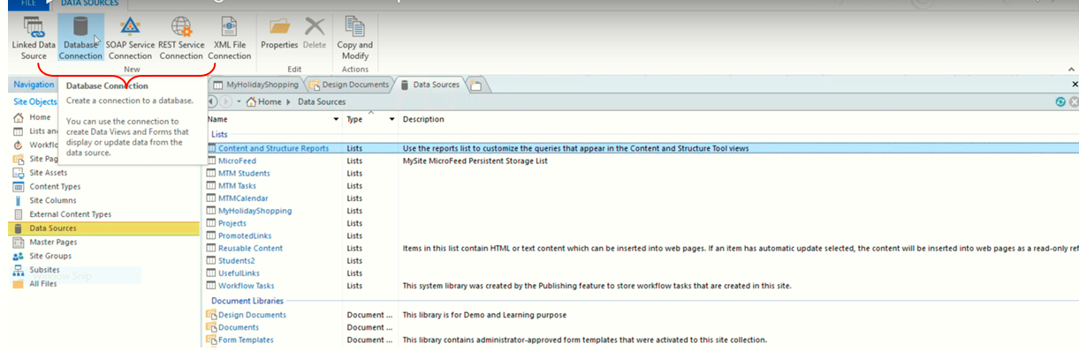

Site group**:**

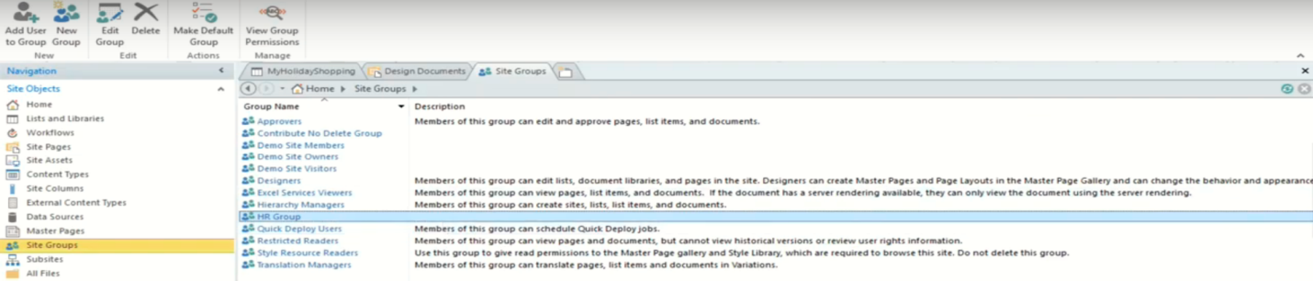

Subsite:

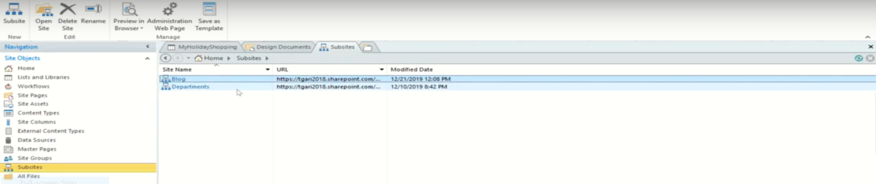

Blog:

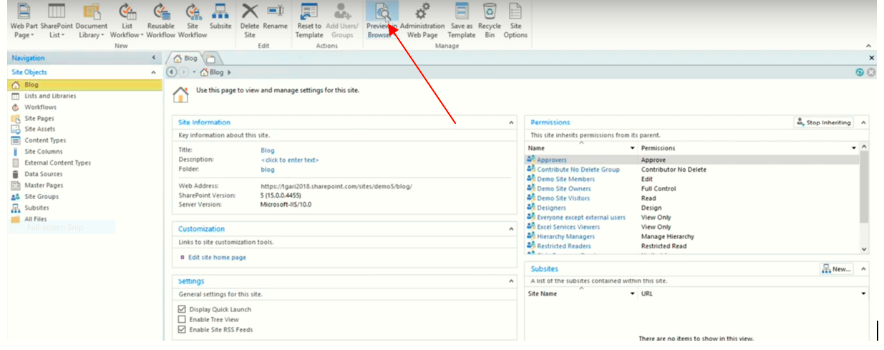

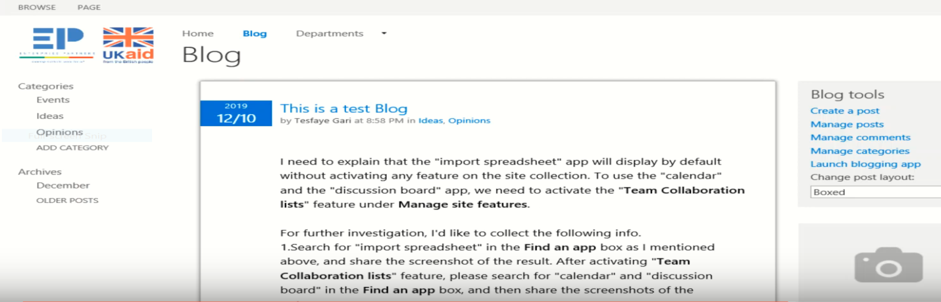

Default pages**:**

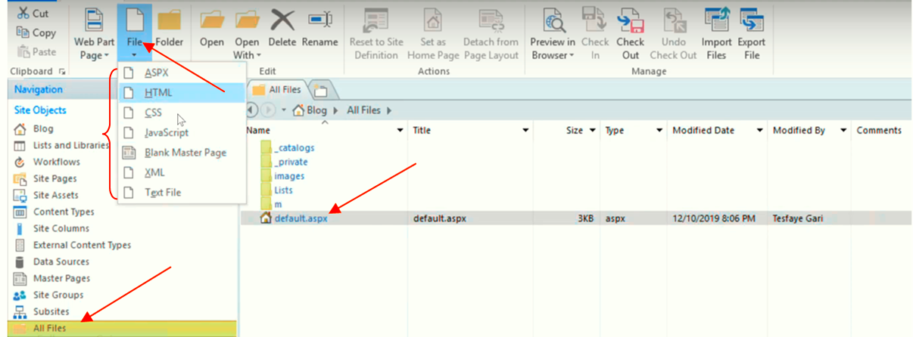

**Remember default/home page.aspx**

**We can add (ASPX,HTML,CSS,JavaScript…) on the root**

#### All File

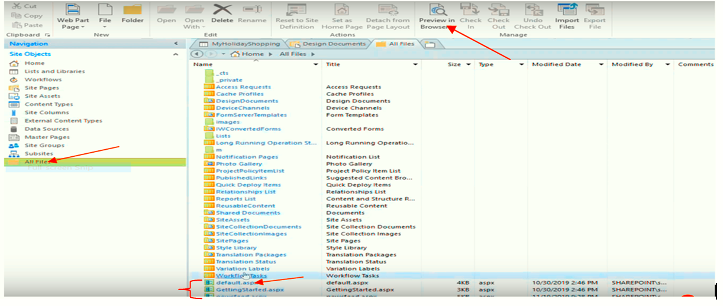

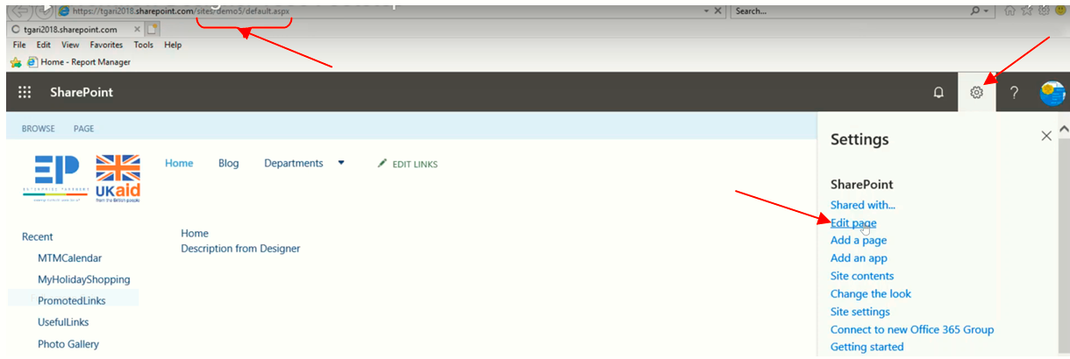

We get two column web part

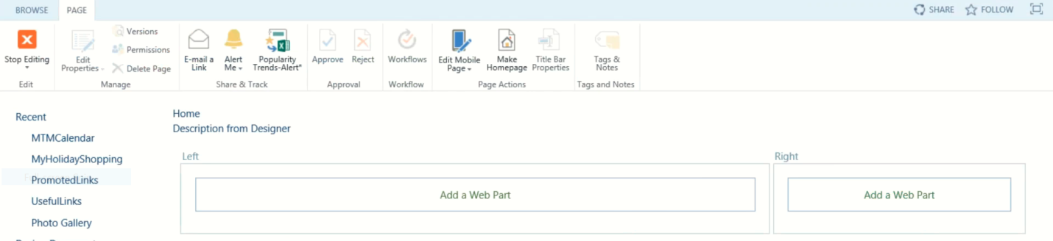

This is Really good default

**Getting started**

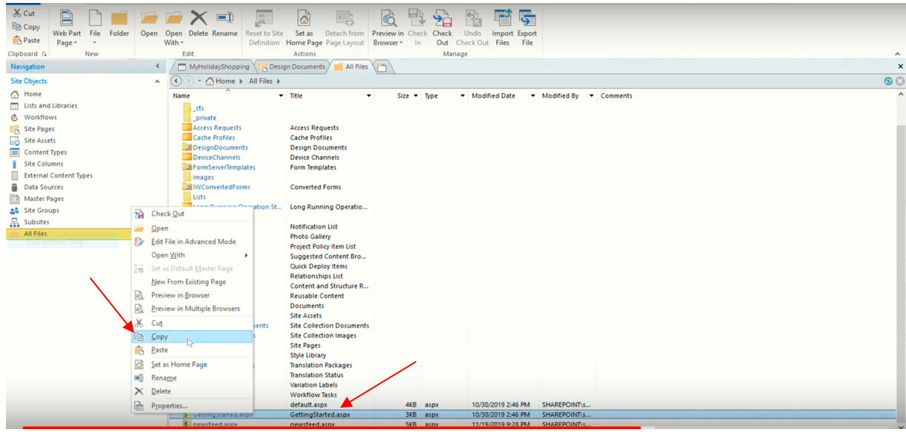

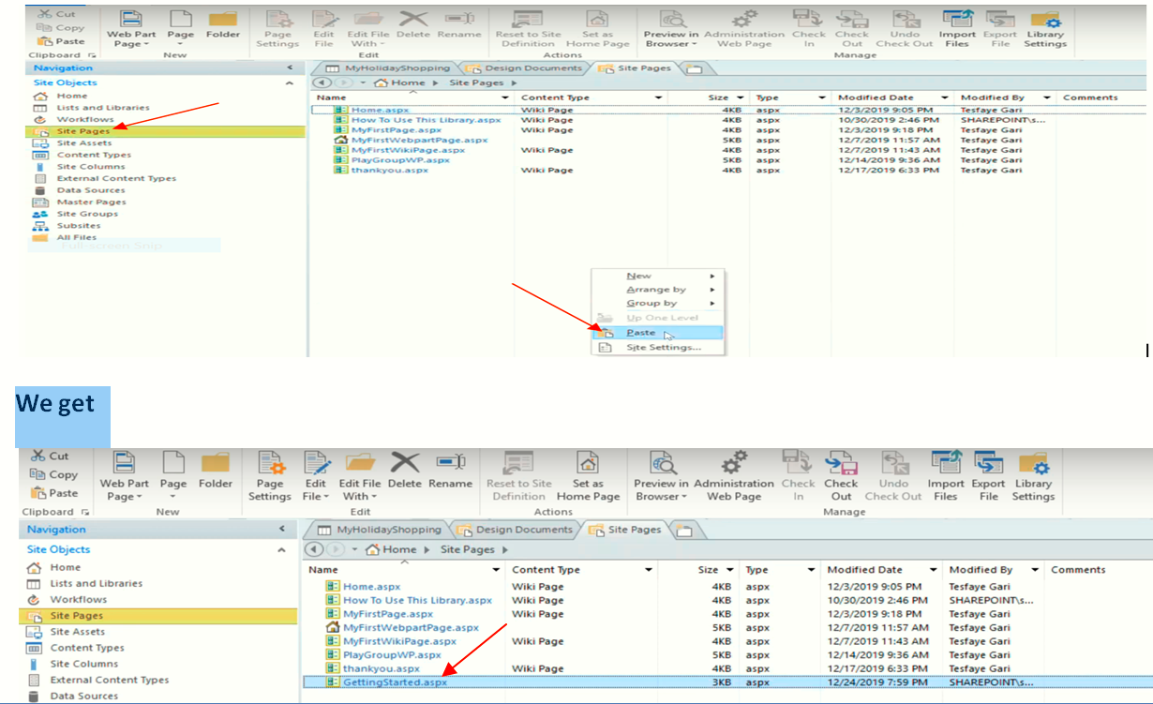

**Look the following**

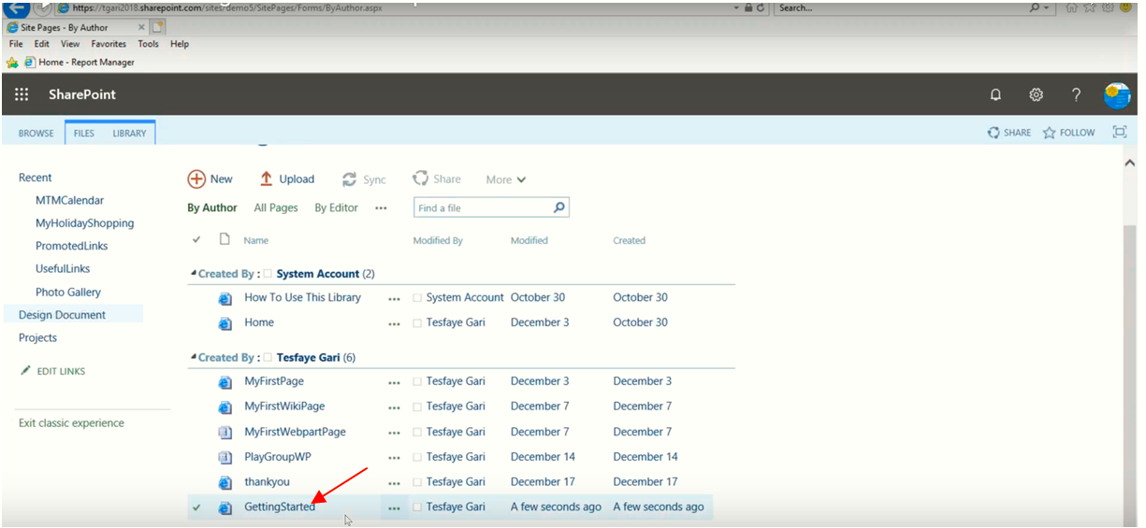

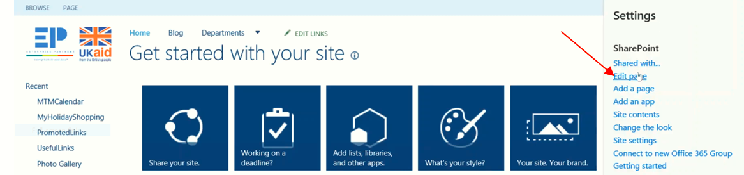

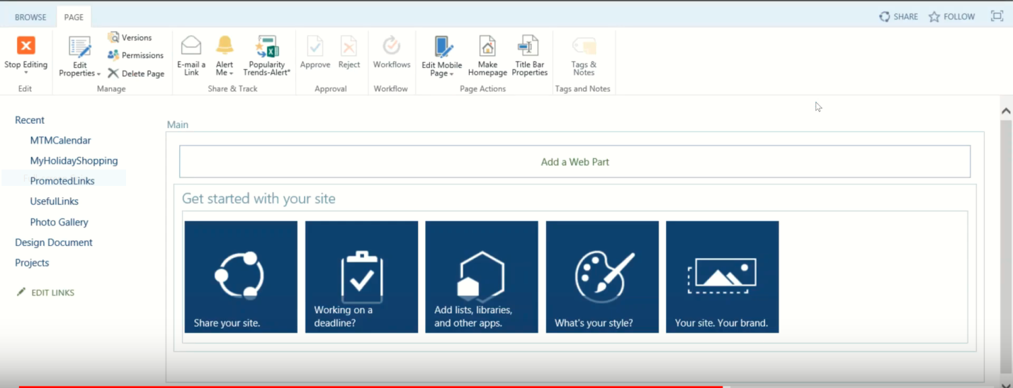

**Thankyou page: if we want to copy paste our file, we can do.**

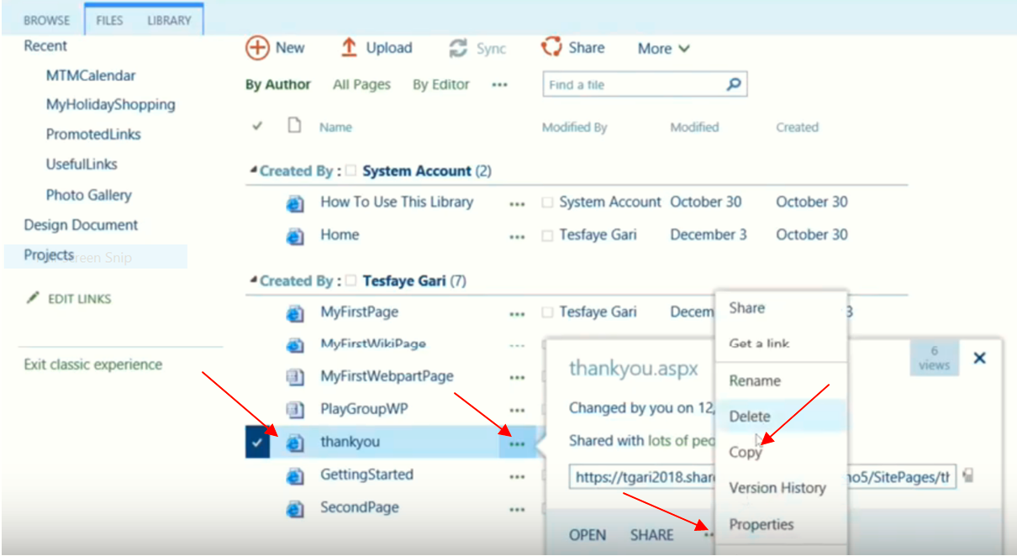

Go back All Files

C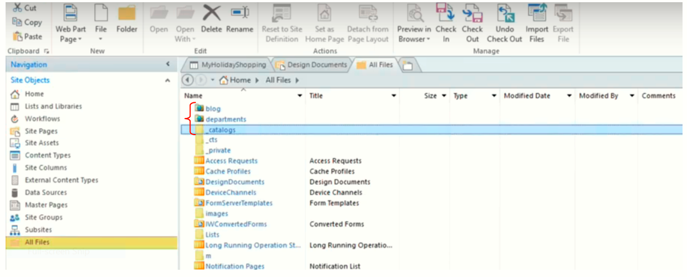

Catalog**:**

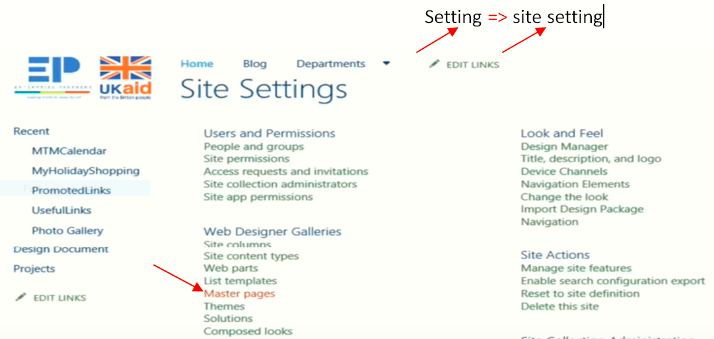

#### create New Form

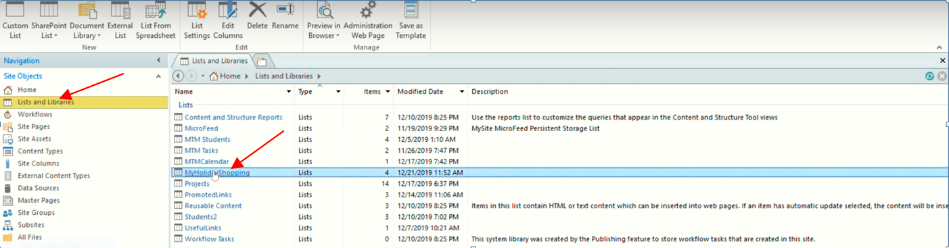

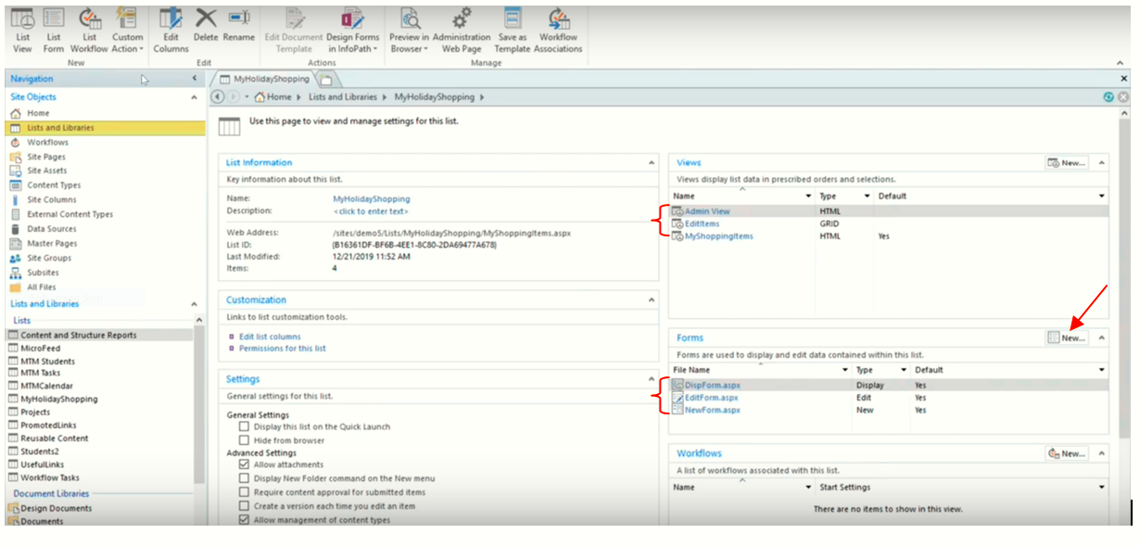

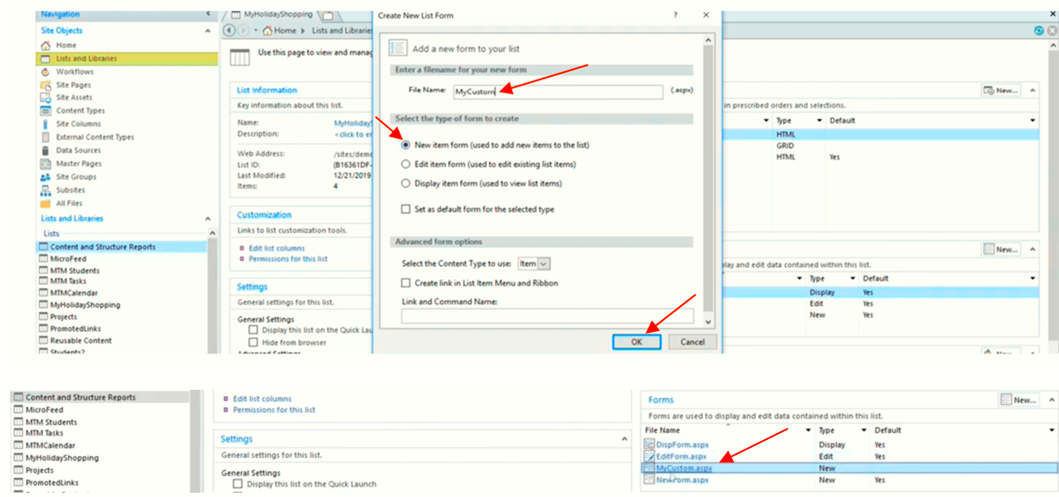

Then we work on our Form.

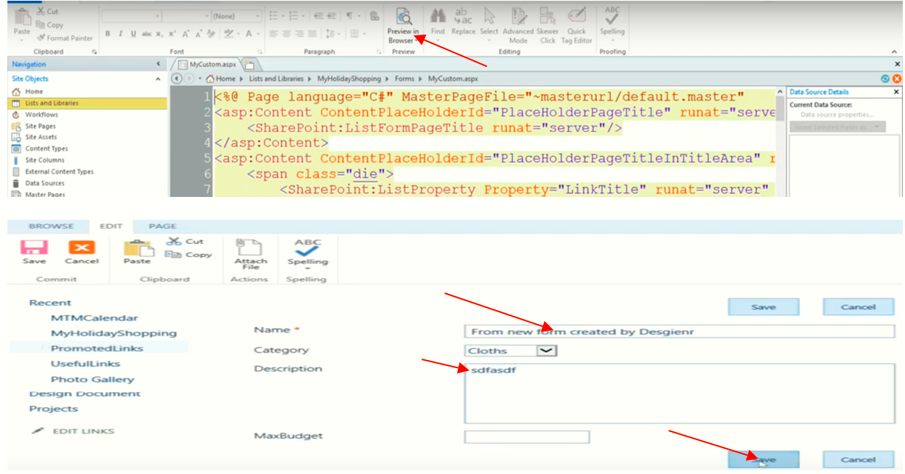

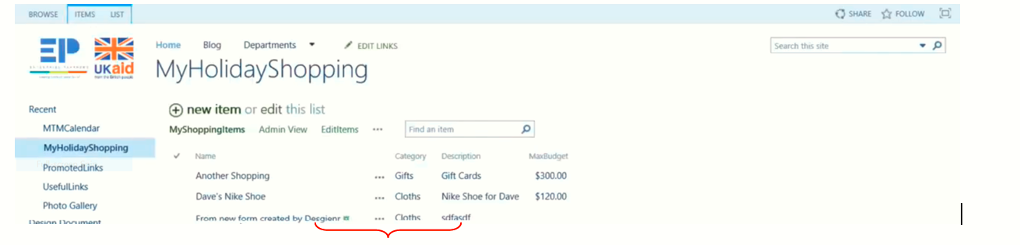

**To delete Description from the form**

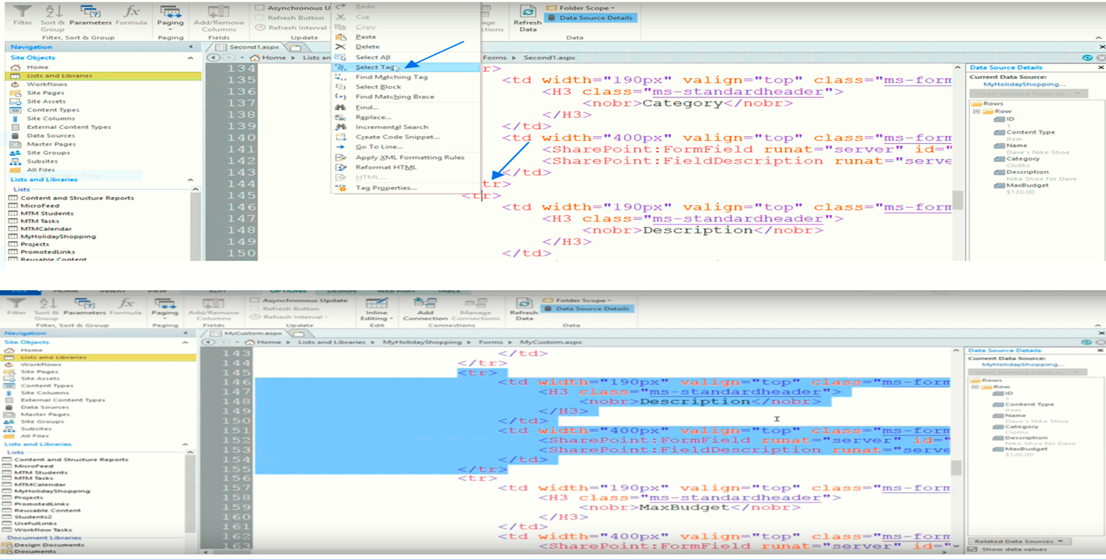

**NB**: Read 003 Customization Using SP Designer

**End of class 12**